Office of Public Health Investigations and Epidemiology

Healthcare-Associated Infection State Report:
2015 Facility Data
1st Edition

Steve Sisolak
Governor

Richard Whitley, MS
Director

Lisa Sherych
Administrator

Ihsan Azzam, Ph.D., M.D.
Chief Medical Officer

Nevada Department of Health and Human Services
Division of Public and Behavioral Health
Table of Contents
Executive Summary 3
Table 1: Executive Summary of Healthcare-Associated Infections in Nevada Hospitals (2015) 3
Background 4
Methods 4
Figure 1: Facility-specific Annual CLABSI data in 2015. n=39 units 7
Table 2. Facility-specific Annual CLABSI data in 2015. n=39 units 8
Figure 2. Changes overtime in CLABSI SIR in US hospitals using 2006-2008 baseline, NHSN 2006 – 2015 10
Methicillin-resistant Staphylococcus aureus Bloodstream Infection (MRSA BSI) 12
Figure 3. Changes over time in hospital-onset MRSA bacteremia SIR in US hospitals using 2011 baseline, NHSN 2011-2015 13
Figure 4. Facility Specific annual MRSA data 2015. n=21 14
Table 3. Facility Specific annual MRSA data 2015. n=21 15
Surgical Site Infections (SSI) 16
Figure 5. Changes over time in SSI SIR after any of the 10 surgical improvement project procedures in US hospitals using 2006-8 baseline, NHSN 2010-2014 17
Surgical Site Infection data for Coronary Artery Bypass Graft with Both Chest and Donor Site Incisions (CBGB) 18
Figure 6: Facility-Specific Annual Data for Coronary Bypass Graft with Both Chest and Donor Site Incisions (CBGB) 2015. n=13 18
Table 4: Facility-Specific Annual Data for Coronary Bypass Graft with Both Chest and Donor Site Incisions (CBGB) 2015. n=13 19
Surgical Site Infection data for Laminectomy (SSI-LAM) 20
Figure 7. Facility-specific Annual SSI Data for Laminectomy (LAM) in 2015 (n=15) 20
Table 5. Facility-specific Annual SSI Data for Laminectomy (LAM) in 2015 (n=15) 21
Surgical Site Infection data for Hip Prosthesis (SSI-HPRO) 22
Figure 8: Facility-specific Annual SSI Data for Hip Prosthesis (HPRO) in 2015. n=19 22
Table 6. Facility-specific Annual SSI Data for Hip Prosthesis (HPRO) in 2015. n=19 23
Surgical Site Infection data for Knee Prosthesis (SSI-KPRO) 24
Figure 9: Facility Specific Annual SSI Data for Knee Prosthesis (KPRO) in 2015. n=19 25
Table 7: Facility Specific Annual SSI Data for Knee Prosthesis (KPRO) in 2015. n=19 26
Conclusion 27
Acknowledgments…………………………………………………………………………………………28
References 29

Executive Summary
The Nevada Division of Public and Behavioral Health is committed to protecting patients and healthcare workers from adverse healthcare events and promoting safety, quality, and value in healthcare delivery. This report provides a summary of select Healthcare-Associated Infections (HAIs) across four healthcare settings; acute care hospitals (ACHs), critical access hospitals (CAHs), inpatient rehabilitation facilities (IRFs), and long-term acute care hospitals (LTACHs). The designation of CAH is assigned by the Centers for Medicare and Medicaid Services (CMS) to hospitals which have 25 or fewer acute care inpatient beds and that maintain an annual average length of stay of 96 hours or less for acute care patients. IRFs include hospitals, or parts of hospitals, which provide intensive rehabilitation services using an interdisciplinary team approach. LTACHs provide treatment for patients who are generally very sick and who stay, on average, more than 25 days. The Healthcare-Associated Infections 2014-2015 State Report provides data on central line-associated bloodstream infections (CLABSIs), methicillin-resistant Staphylococcus aureus (MRSA) bloodstream events, and surgical site infections (SSIs).

Table 1: Executive Summary of Healthcare-Associated Infections in Nevada Hospitals (2015)
Healthcare-associated Infection Type | National Baseline Years | HHS Reduction Target* | # Hospitals Reporting | 2013 NV SIR | 2014 NV SIR | 2015 NV SIR | 2015 SIR Meets HHS Reduction Target? | Improved Comparing with 2014 NV SIR?
CLABSI | 2006-2008 | 50% (SIR=0.5) | 45* | 0.622 | 0.587 | 0.58 | No | No Change
MRSA | 2010-2011 | 25% (SIR=0.75) | 21 | 0.737 | 1.052 | 0.95 | No | Yes
SSI: CBGB | 2006-2008 | 25% (SIR=0.75) | 13 | 0.353 | 0.458 | 0.50 | Yes | No
SSI: LAM | 2006-2008 | 25% (SIR=0.75) | 15 | 0.582 | 0.583 | 0.70 | Yes | No
SSI: HPRO | 2006-2008 | 25% (SIR=0.75) | 19 | 0.895 | 0.873 | 0.81 | No | Yes
SSI: KPRO | 2006-2008 | 25% (SIR=0.75) | 19 | 0.826 | 0.549 | 0.64 | Yes | No

*The U.S. Department of Health and Human Services (HHS) developed 5-year target goals for HAI reductions in 2009: https://health.gov/hcq/prevent-hai-measures.asp
* Nevada made some progress in 2015 for reduction of SIR compared to the 2014 SIR and HHS reduction targets.
*Individual neonatal intensive care units (NICU) are counted separately as data is risk-adjusted for birthweight.
What is the Standardized Infection Ratio (SIR)?
The SIR is a summary statistic that can be used to track HAI prevention progress over time. The SIR summary measure shows whether Nevada hospitals, in aggregate, had significantly more, fewer, or about the same number of HAIs compared to the number predicted for all facilities based on national baseline data for a specific time period. The SIR is currently not calculated when the predicted number of infections is less than one.
Lower SIRs represent more improvement. While a SIR less than 1.0 is an indicator that fewer infections are occurring than are predicted, new target metrics are increasingly being set much lower than 1.0, including the HHS CLABSI target SIR of 0.5.
The SIR for the facility or state is adjusted to account for factors that might cause infection rates to be higher or lower, such as hospital size, teaching status, type of patients the hospital serves, surgery and patient characteristics. This number can be used to track HAI prevention progress over time and is compared to the national baseline. The SIR targets measure progress in reducing HAIs using national baseline data to determine the risk-adjusted estimate.

Background
What are Healthcare-Associated Infections?
According to the Centers for Disease Control and Prevention (CDC), HAIs are a threat to patient safety. HAIs occur when healthcare workers neglect to follow best practices such as hand hygiene, proper use of personal protective equipment (PPE), proper cleaning of environmental surfaces, etc., which result in a patient contracting a preventable infection. To promote the prevention of HAIs, Nevada adopted regulations to make the following HAIs reportable beginning in 2011: CLABSIs, including MRSA bloodstream infections, and SSIs for hospitals which have an average daily census of 25 or more. These infections are reported to the National Healthcare Safety Network (NHSN) database that was created by CDC to collect data on HAIs and other healthcare-associated data. Nevada’s legislative mandates regarding HAIs can be found at https://www.leg.state.nv.us/NAC/NAC-439.html#NAC439Sec935.
This report will show the progress of hospitals in Nevada in preventing HAIs among those who are treated in their facilities.

How to Use This Report
The report compares the HHS reduction targets to the 2014-2015 Nevada SIRs and the 2006-2008 baseline. Where an SIR for a facility is zero or unavailable, a direct comparison cannot be made. Calculation of SIRs from NHSN data is only done if the number of cases predicted is greater than or equal to one. Facilities with no data reported or zero infections reported do not have data displayed.

Intended Audience
This report is intended for the public, healthcare workers, providers, and those who work to protect public health. The tables in the report summarize basic HAI data reported by healthcare facilities to NHSN. This includes CLABSI, MRSA, SSI such as Coronary artery Bypass Graft with Both chest and donor site incisions (CBGB), Surgical Site Infection data for Laminectomy (SSI-LAM), Surgical Site Infection data for Hip Prosthesis (SSI-HPRO), and Surgical Site Infection data for Knee Prosthesis (SSI-KPRO).

Methods
Data collection
Nevada healthcare facilities report HAIs to the state using NHSN. NAC 439.925 requires medical facilities or skilled nursing facilities providing medical services and care to an average of 25 or more patients during each business day in the immediately preceding calendar year to enter their reportable HAIs into NHSN. Nevada currently has 61 licensed hospitals. The hospitals mentioned in this report meet the above definition of a mandatory reporter. To identify a HAI, hospitals used definitions created by NHSN. Please visit https://www.cdc.gov/hai/ for more information on reportable HAIs and their definitions. The NHSN database was developed by the CDC to keep track of HAIs among the states. Healthcare facilities were first required to report HAIs to NHSN in NRS 439.847 in 2011. NHSN provides facilities, states, regions, and the country with data needed to identify problem areas and measure the progress of prevention efforts to ultimately eliminate HAIs.

NHSN has several tools to aid in monitoring HAIs which allow users to run and modify reports. Reports can be adjusted to reflect HHS goals, National SIRs, or custom SIR goals. Tools include Targeted Assessment for Prevention (TAP) reports, which measure the burden of infections in a facility by unit, thereby helping facilities to target infection control practices. For more information on TAP reports, please visit https://www.cdc.gov/hai/prevent/tap.html.
This progress report contains 2014 and 2015 data from state-licensed healthcare facilities which met the definition for mandated reporters. For more information regarding NRS 439.847 please visit http://www.leg.state.nv.us/NRS/NRS-439.html.

The SIR is | Implication
More than 1 | There was an increase in the number of infections reported compared to what is predicted.
1 | The number of infections match what is predicted.
Less than 1 | There was a decrease in the number of infections reported compared to what is predicted.

Table Elements:
Healthcare Facility Name: Healthcare facilities which report into NHSN.
Central Line Days: The total number of patients with at least one central line in place; the count is performed each day at the same time, and each patient with a central line on a day is counted as a central line-day.
Total Observed Infections: The total number of infections reported by the hospital.
Predicted Number of Infections: This is calculated by CDC using data from HAI events that occurred during the baseline period.
SIR in 2014 & 2015: The SIR value is calculated by dividing the actual observed infections by the number of predicted infections.
Improvement Based on previous SIR: A comparison of the HAI occurrence during the reporting period. Each facility’s number of infections and predicted value is used to calculate the SIR.

- An SIR greater than 1.0 indicates that more HAIs were observed than predicted.
- An SIR less than 1.0 indicates that fewer HAIs were observed than predicted.
- Fields with no value indicate that the facility did not report data for that period.
- Not applicable (“N/A”) indicates data was not available for both 2014 and 2015 to make a comparison or that the facility had zero infections.
A “central line” or “central venous catheter” is a tube that is placed in a patient’s large vein to administer medication, fluids, or nutrition, or for blood collection. A bloodstream infection may occur when the tube that is placed in a large vein is inserted incorrectly or is improperly cleaned or cared for, thus introducing dangerous microbes into the bloodstream. Bloodstream infections are serious infections typically causing prolonged hospital stays, increased costs, and higher risk of mortality. CLABSIs are a type of preventable infection that causes thousands of deaths per year. For more information, visit http://www.cdc.gov/nhsn/PDFs/pscManual/4PSC_CLABScurrent.pdf.

For general acute care hospitals, the number of predicted CLABSIs is risk-adjusted based on the following variables found to be statistically significant predictors:
• Type of patient care location
• Hospital affiliation with a medical school
• Bed size of the facility
• Facility type (based on NHSN enrollment)

For neonatal intensive care unit (NICU) locations in acute care hospitals, the number of predicted CLABSIs is risk-adjusted based on the following variable:
• Birthweight

For long-term acute care hospitals, the number of predicted CLABSIs is risk adjusted based on the following variables:
• Type of patient care location
• Bed size of the facility
• Average length of stay
• Proportion of admissions on a ventilator
• Proportion of admissions on hemodialysis

There are 33 healthcare facilities which reported CLABSI data in Nevada. The Centers for Disease Control and Prevention provides the state and each hospital with the number of predicted infections. There were 345 reported CLABSIs in 2015 which occurred in Nevada. Of 39 units within healthcare facilities (Individual NICUs are counted separately as data is risk-adjusted for birthweight) which reported CLABSI data, 11 units showed improvement, 12 units showed no improvement, and the SIR could not be calculated for 16 units as their number of predicted infections was less than one. The state had minimal improvement overall in SIRs from 2014 to 2015 with a drop in the annual SIR from 0.59 in 2014 to 0.58 in 2015. Nationally, there has been significant progress in the prevention of CLABSI with a 50% drop in CLABSI between 2008 and 2016 as shown in Figure 2. Figure 1 and Table 2 displays facility-specific annual CLABSI data for 2015.
Predicted Infections for NV 2015 | Observed Infections for NV 2015
594 | 345

Figure 1: Facility-specific Annual CLABSI data in 2015. n=39 units
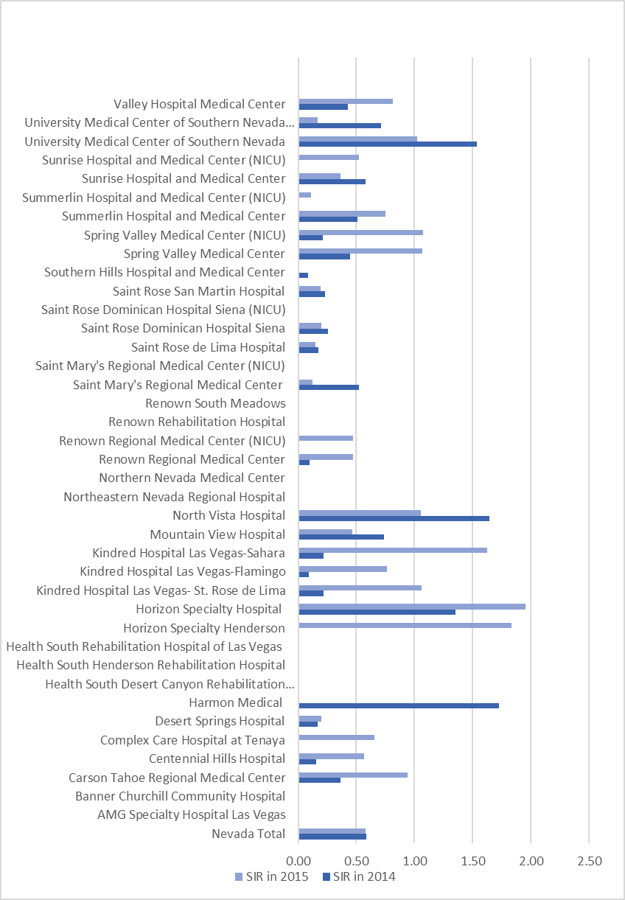
*Reporting is facility wide and ICU is included in the above CLABSI counts.
Table 2. Facility-specific Annual CLABSI data in 2015. n=39 units
Hospital Name | Central Line Days (2015) | # of Observed Infections (2015) | # of Predicted Infections (2015) | SIR in 2014 | SIR in 2015 | Improvement Based on 2014 SIR
Nevada Total | 372,189 | 345 | 594.14 | 0.59 | 0.58 | No Improvement
AMG Specialty Hospital Las Vegas | 3,302 | 0 | 2.97 | N/A | 0.00 | N/A
Banner Churchill Community Hospital | 320 | 0 | 0.41 | . | 0.00 | N/A
Carson Tahoe Regional Medical Center | 6,487 | 9 | 9.54 | 0.36 | 0.94 | No Improvement
Centennial Hills Hospital | 10,877 | 9 | 15.95 | 0.16 | 0.56 | No Improvement
Complex Care Hospital at Tenaya | 16,968 | 10 | 15.27 | . | 0.66 | N/A
Desert Springs Hospital | 16,236 | 5 | 25.02 | 0.17 | 0.20 | No Improvement
Harmon Medical | 801 | 0 | 0.96 | 1.73 | 0.00 | Improved
Health South Desert Canyon Rehabilitation Hospital | No CLABSI data for IRF in NHSN | . | . | . | . | N/A
Health South Henderson Rehabilitation Hospital | No CLABSI data for IRF in NHSN | . | . | . | . | N/A
Health South Rehabilitation Hospital of Las Vegas | No CLABSI data for IRF in NHSN | . | . | . | . | N/A
Horizon Specialty Henderson | 6,524 | 11 | 5.99 | . | 1.84 | N/A
Horizon Specialty Hospital | 4,551 | 8 | 4.10 | 1.35 | 1.95 | No Improvement
Kindred Hospital Las Vegas- St. Rose de Lima | 5,474 | 6 | 5.65 | 0.22 | 1.06 | No Improvement
Kindred Hospital Las Vegas-Flamingo | 12,243 | 9 | 11.84 | 0.09 | 0.76 | No Improvement
Kindred Hospital Las Vegas-Sahara | 10,256 | 15 | 9.23 | 0.22 | 1.63 | No Improvement
Mountain View Hospital | 29,055 | 23 | 49.53 | 0.74 | 0.46 | Improved
North Vista Hospital | 6,797 | 9 | 8.56 | 1.64 | 1.05 | Improved
Northeastern Nevada Regional Hospital | 268 | 0 | 0.33 | . | 0.00 | N/A
Northern Nevada Medical Center | . | . | . | 0.00 | . | N/A
Renown Regional Medical Center | 41,874 | 38 | 80.71 | 0.10 | 0.47 | No Improvement
Renown Regional Medical Center (NICU) | 3,184 | 3 | 6.32 | . | 0.47 | N/A
Renown Rehabilitation Hospital | No CLABSI data for IRF in NHSN | . | . | . | . | N/A
Renown South Meadows | 1,717 | 0 | 2.44 | 0.00 | 0.00 | N/A
Saint Mary's Regional Medical Center | 4,837 | 1 | 8.37 | 0.53 | 0.12 | Improved
Saint Mary's Regional Medical Center (NICU) | 1,396 | 0 | 2.63 | . | 0.00 | N/A
Saint Rose de Lima Hospital | 8,406 | 2 | 13.43 | 0.17 | 0.15 | Improved
Saint Rose Dominican Hospital Siena | 17,300 | 3 | 14.96 | 0.26 | 0.20 | Improved
Saint Rose Dominican Hospital Siena (NICU) | 1,211 | 0 | 2.65 |  | 0.00 | N/A
Saint Rose San Martin Hospital | 9,902 | 3 | 15.40 | 0.23 | 0.20 | Improved
Southern Hills Hospital and Medical Center | 8,264 | 0 | 11.75 | 0.09 | 0.00 | Improved
Spring Valley Medical Center | 13,792 | 22 | 20.62 | 0.45 | 1.07 | No Improvement
Spring Valley Medical Center (NICU) | 1,208 | 3 | 2.79 | 0.22 | 1.07 | No Improvement
Summerlin Hospital and Medical Center | 21,129 | 24 | 32.03 | 0.51 | 0.75 | No Improvement
Summerlin Hospital and Medical Center (NICU) | 3,988 | 1 | 9.20 |  | 0.11 | N/A
Sunrise Hospital and Medical Center | 47,912 | 33 | 90.99 | 0.58 | 0.36 | Improved
Sunrise Hospital and Medical Center (NICU) | 6,791 | 8 | 15.36 | . | 0.52 | N/A
University Medical Center of Southern Nevada | 29,103 | 64 | 62.47 | 1.54 | 1.02 | Improved
University Medical Center of Southern Nevada (NICU) | 2,643 | 1 | 6.03 | 0.71 | 0.17 | Improved
Valley Hospital Medical Center | 17,373 | 25 | 30.65 | 0.43 | 0.82 | No Improvement

*Not applicable (“N/A”) indicates data was not available for both 2014 and 2015 to make a comparison or when comparing zero (0) infections in 2014 to zero (0) infections in 2015. The SIR is only calculated if the number of expected HAIs is greater than 1.

Figure 2. Changes overtime in CLABSI SIR in US hospitals using 2006-2008 baseline, NHSN 2006 – 2015

Ways the patient and their family can prevent a CLABSI:
- Research the hospital, if possible, to learn about its CLABSI rate.
- Speak up about any concerns so that healthcare personnel are reminded to follow the proper infection prevention practices.
- Ask a healthcare provider if the central line is necessary. If so, ask them to help you understand the need for it and how long it will be in place.
- Pay attention to the bandage and the area around it. If the bandage comes off or if the bandage or area around it is wet or dirty, tell a healthcare worker right away.
- Do not get the central line or the central line insertion site wet.
- Tell a healthcare worker if the area around the catheter is sore, red, or if the patient has a fever or chills.
- Do not let any visitors touch the catheter or tubing.
- The patient should avoid touching the tubing as much as possible.
- In addition, everyone visiting the patient must wash their hands, both before and after they visit.
- For more information visit: http://www.cdc.gov/HAI/bsi/CLABSI-resources.html.

Methicillin-resistant Staphylococcus aureus Bloodstream Infection (MRSA BSI)

According to the CDC, MRSA is a type of staph bacteria that is resistant to some antibiotics. MRSA is a common healthcare-associated infection and can cause skin infections in the community as well as serious bloodstream infections in healthcare settings.
The numbers of predicted MRSA events in acute care hospitals and LTACs are risk-adjusted based on the following variables found to be statistically significant predictors of incidence:
- Inpatient community-onset prevalence rate
- Average length of stay
- Medical school affiliation
- Facility type
- Number of ICU beds
- Ventilator admission* (LTAC ONLY)

Among 21 healthcare facilities that report MRSA data into NHSN, there were 71 MRSA bloodstream infections reported in 2015. The predicted number of MRSA BSI was 75. Nine facilities showed improvement, five facilities showed no improvement, and the SIR could not be calculated for seven facilities which had predicted infections less than one.

Overall, healthcare facilities that reported MRSA infections into NHSN had some improvement when comparing their 2015 SIR of 0.95 value with the 2014 SIR of 1.05. Table 3 and Figure 4 displays facility specific annual MRSA data for 2015. The predicted and observed number of MRSA BSI infections in Nevada in 2015. Figure 3 shows national data in which there has been great progress in preventing MRSA-BSI since 2005, but a decline in rates has slowed since 2011.

Predicted Infections for NV 2015 | Observed Infections for NV 2015
75 | 71

Figure 3. Changes over time in hospital-onset MRSA bacteremia SIR in US hospitals using 2011 baseline, NHSN 2011-2015

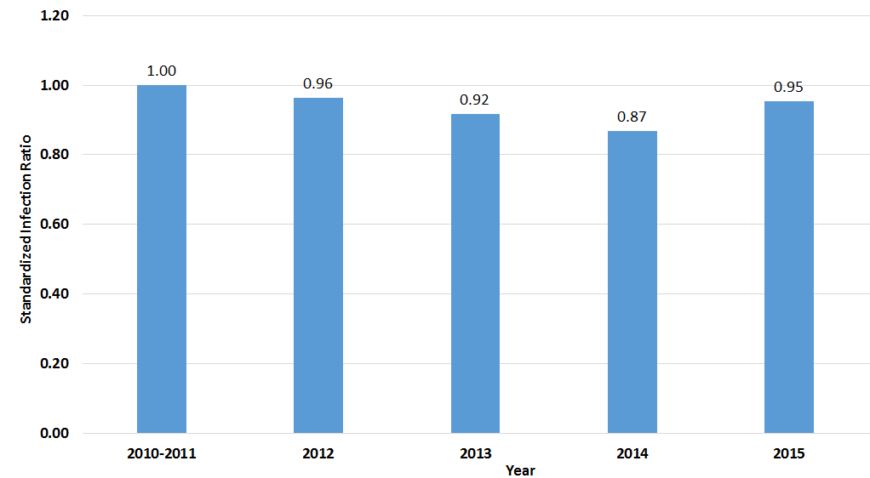

Ways the patient and their family can prevent MRSA-BSI:

• Continue antibiotics as prescribed by your doctor. Do not take half-doses or stop before you complete your prescribed course.
• Wash your hands often, especially before and after changing your wound dressing or bandage.
• People who live with you should wash their hands often as well.
• Keep any wounds clean and change bandages as instructed until healed.
• Avoid sharing personal items such as towels or razors.
• Wash and dry your clothes and bed linen.
• For more information please visit: https://www.cdc.gov/mrsa/pdf/SHEA-mrsa_tagged.pdf.

Figure 4. Facility Specific annual MRSA data 2015. n=21

Table 3. Facility Specific annual MRSA data 2015. n=21
Hospital Name | Patient Days (2015) | # of Observed Infections (2015) | # of Predicted Infections (2015) | 2014 SIR | 2015 SIR | Improvement Based on 2014 SIR
Nevada Total | 1,304,669 | 71 | 74.70 | 1.05 | 0.95 | Improved
Banner Churchill Community Hospital | 5,990 | 0 | 0.22 | . | . | N/A
Carson Tahoe Health System | 51,839 | 3 | 2.26 | 0.00 | 1.33 | No Improvement
Centennial Hills Hospital | 51,142 | 2 | 1.95 | 1.79 | 1.02 | Improved
Desert Springs Hospital | 63,514 | 3 | 2.94 | 0.81 | 1.02 | No Improvement
Harmon Medical and Rehabilitation Hospital | 3,262 | 0 | 0.12 | 4.16 | . | N/A
Mountain View Hospital | 99,261 | 2 | 4.02 | 1.34 | 0.50 | Improved
North Vista Hospital | 33,886 | 4 | 1.58 | 1.78 | 2.54 | No Improvement
Northeastern Nevada Regional Hospital | 6,705 | 0 | 0.24 | . | . | N/A
Northern Nevada Medical Center | 11,525 | 0 | 0.45 | . | . | N/A
Renown Regional Medical Center | 172,608 | 5 | 17.50 | 0.48 | 0.29 | Improved
Renown South Meadows | 11,563 | 0 | 0.54 | . | . | N/A
Saint Mary's Regional Medical Center | 64,013 | 1 | 2.78 | 0.76 | 0.36 | Improved
Saint Rose de Lima Hospital | 24,236 | 0 | 0.87 | 0.00 | . | N/A
Saint Rose Dominican Hospital Siena | 63,563 | 0 | 2.28 | 0.46 | 0.00 | Improved
Saint Rose San Martin Hospital | 33,511 | 0 | 1.26 | 0.00 | 0.00 | N/A
Southern Hills Hospital | 37,970 | 0 | 1.40 | 1.48 | 0.00 | Improved
Spring Valley Medical Center | 64,755 | 0 | 2.32 | 1.20 | 0.00 | Improved
Summerlin Hospital and Medical Center | 98,403 | 4 | 5.45 | 1.02 | 0.73 | Improved
Sunrise Hospital and Medical Center | 191,729 | 18 | 12.44 | 0.69 | 1.45 | No Improvement
University Medical Center of Southern Nevada | 140,887 | 21 | 10.51 | 1.60 | 2.00 | No Improvement
Valley Hospital Medical Center | 74,307 | 8 | 3.59 | 2.65 | 2.23 | Improved
The SIR is only calculated if the number of predicted HAIs is greater than 1.
*Not applicable (“N/A”) indicates data was not available for both 2014 and 2015 to make a comparison or when comparing zero (0) infections in 2014 to zero (0) infections in 2015. The SIR is only calculated if the number of expected HAIs is greater than 1.

Surgical Site Infections (SSI)
Surgical site infections are infections that develop in the surgical site after surgery. Some surgical sites may involve other tissues under the skin, organs, or implanted material. We track the following SSIs: coronary artery bypass graft with both chest and donor site incisions, laminectomy, hip prosthesis surgery, and knee prosthesis surgery. According to the CDC, SSIs overall are associated with a mortality rate of 3%, and 75% of SSI-associated deaths are directly attributable to the SSI. SSIs are preventable when proper surgical techniques are being practiced, such as having proper infection control practices in place, sterilization methods, barriers, surgical technique and proper care of the wound after the surgery.

The number of predicted events for SSI is risk-adjusted based on the several variables found to be statistically significant predictors of SSIs and differs by type of procedure. These variables are outlined in Tables 3a-3f of the CDC guide to the NHSN SIR. Figure 5 shows a decline in the national SSI SIR from 2010-2012 when the SIR dropped from 0.93 to 0.80. There was a slight increase of the national SIR from 2012-2014 from 0.80 to 0.83.

Nevada focuses on Coronary Artery Bypass Graft with Both chest and donor site incisions (CBGB), Surgical Site Infection data for Laminectomy (SSI-LAM), Surgical Site Infection data for Hip Prosthesis (SSI-HPRO), and Surgical Site Infection data for Knee Prosthesis (SSI-KPRO). Nationally, there has been a year-to-year decline in the SIRs of SSIs between 2010 and 2012 but no improvement was seen from 2013 onward. Surgical care improvement will require collaborative efforts with the surgical community to develop and implement strategies to reduce infections dealing with specific procedures. Of note, not all hospitals perform the reportable procedures and therefore some are not listed in the tables below.

Overall SSI data are not included in the report as they were not verifiable; this is due to an error which has been reported to NHSN wherein the number of predicted infections is not available for most facilities.

Figure 5. Changes over time in SSI SIR after any of the 10 surgical improvement project procedures in US hospitals using 2006-8 baseline, NHSN 2010-2014
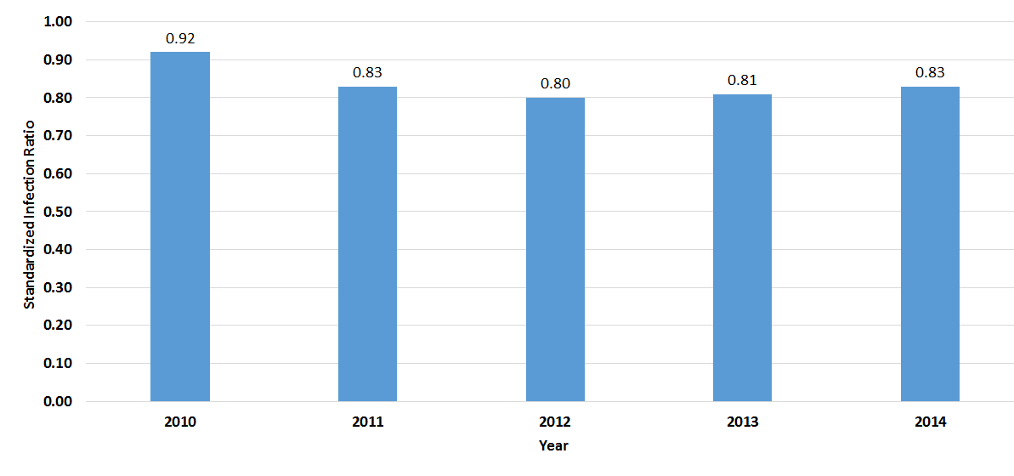

Ways to prevent SSIs

Before surgery:
- Tell your doctor about other medical problems you may have. Health problems such as allergies, diabetes, and obesity could affect your surgery and your treatment.
- Quit smoking. Patients who smoke get more infections. Talk to your doctor about how you can quit before your surgery.
- Do not shave near where you will have surgery. Shaving with a razor can irritate your skin and make it easier to develop an infection.
At the time of surgery:
- Speak up if someone tries to shave you with a razor before surgery. Ask why you need to be shaved and talk with your surgeon if you have any concerns.
After surgery:
- If you do not see your providers clean their hands, please ask them to do so.
- Family and friends who visit you should not touch the surgical wound or dressings.
- Family and friends should clean their hands with soap and water or an alcohol-based hand rub before and after visiting you. If you do not see them clean their hands, ask them to clean their hands.
- Make sure you understand how to care for your wound before you leave the hospital.
- Always clean your hands before and after caring for your wound.

Surgical Site Infection data for Coronary Artery Bypass Graft with Both Chest and Donor Site Incisions (CBGB)
Among 13 hospitals and 1,748 procedures in 2015, there were 18 reported infections associated with CBGB and 35 predicted by NHSN. Of 13 healthcare facilities that reported CBGB data, six facilities showed improvement from 2014, four facilities had no improvement, and the SIR could not be calculated for three facilities as they had a number of predicted infections less than one.

Overall, Nevada healthcare facilities that reported CBGB into NHSN did not show improvement when comparing the 2015 SIR of 0.51 to the 2014 SIR of 0.458. Table 4 and Figure 6 show facility-specific annual data for CBGB in Nevada.

Expected Infections for NV 2015 | Actual Infections for NV 2015
35 | 18

Figure 6: Facility-Specific Annual Data for Coronary Bypass Graft with Both Chest and Donor Site Incisions (CBGB) 2015. n=13

Table 4: Facility-Specific Annual Data for Coronary Bypass Graft with Both Chest and Donor Site Incisions (CBGB) 2015. n=13
Hospital Name | Total Procedures (2015) | # of Observed Infections (2015) | # of Predicted Infections (2015) | 2014 SIR | 2015 SIR | Improvement Based on 2014 SIR
Nevada Total | 1,748 | 18 | 35.45 | 0.458 | 0.51 | No improvement
Carson Tahoe Regional Healthcare | 44 | 0 | 0.89 | 0.90 | . | N/A
Desert Springs Hospital | 124 | 4 | 2.37 | 0 | 1.69 | No Improvement
Mountain View Hospital | 204 | 5 | 4.04 | 0.79 | 1.24 | No improvement
Renown Regional Medical Center | 193 | 0 | 4.16 | 0.24 | 0 | Improved
Spring Valley Medical Center | 132 | 1 | 2.41 | 0 | 0.415 | No improvement
St. Mary's Regional Medical Center | 86 | 1 | 1.48 | 1.32 | 0.68 | Improved
Saint Rose Dominican Hospital Siena | 148 | 1 | 2.59 | 0.89 | 0.39 | Improved
Saint Rose San Martin Hospital | 67 | 0 | 1.56 | . | 0 | N/A
Summerlin Hospital and Medical Center | 123 | 1 | 2.37 | 0.88 | 0.42 | Improved
Sunrise Hospital and Medical Center | 311 | 0 | 7.08 | 0.27 | 0 | Improved
University Medical Center of Southern Nevada | 147 | 3 | 3.23 | 0.45 | 0.93 | No improvement
Valley Hospital Medical Center | 140 | 1 | 2.90 | 0.40 | 0.35 | Improved
North Vista Hospital | 29 | 1 | 0.38 | . | . | N/A

* Not applicable (“N/A”) indicates data was not available for both 2014 and 2015 to make a comparison or when comparing zero (0) infections in 2014 to zero (0) infections in 2015. The SIR is only calculated if the number of expected HAIs is greater than 1.

Surgical Site Infection data for Laminectomy (SSI-LAM)
Among 15 hospitals and 3,350 procedures in 2015, there were 24 reported infections associated with LAM and 34 predicted by NHSN.
Of 15 healthcare facilities which reported LAM data, three facilities showed improvement from 2014, six facilities showed no improvement, and the SIR could not be calculated for six facilities as they had a number of predicted infections less than one.
Overall, Nevada healthcare facilities that reported LAM into NHSN did not show improvement when comparing 2015 SIR of 0.70 to the 2014 SIR of 0.58. Table 5 and figure 7 show facility-specific annual SSI data for laminectomy in Nevada.
Predicted Infections for NV 2015 | Observed Infections for NV 2015
34 | 24

Figure 7. Facility-specific Annual SSI Data for Laminectomy (LAM) in 2015 (n=15)

Hospital Name | Total Procedures (2015) | # of Observed Infections (2015) | # of Predicted Infections (2015) | 2014 SIR | 2015 SIR | Improvement Based on 2014 SIR
Nevada Total | 3,350 | 24 | 34.37 | 0.58 | 0.70 | No Improvement
Carson Tahoe Regional Medical Center | 59 | 1 | 1.10 | . | 0.91 | N/A
Centennial Hills Hospital | 167 | 2 | 2.20 | 0.00 | 0.91 | No Improvement
Desert Springs Hospital | 61 | 0 | 0.59 | . | 0.00 | N/A
Mountain View Hospital | 213 | 2 | 2.17 | 2.32 | 0.92 | Improved
North Vista Hospital | 29 | 1 | 0.38 | . | 2.67 | N/A
Northern Nevada Medical Center | 82 | 0 | 0.88 | . | 0.00 | N/A
Renown Regional Medical Center | 581 | 6 | 5.87 | 0.55 | 1.02 | No Improvement
Saint Rose Dominican Hospital Siena | 244 | 2 | 1.62 | 0.43 | 1.23 | No Improvement
Saint Rose San Martin Hospital | 81 | 2 | 1.10 | 0.84 | 1.82 | No Improvement
Southern Hills Hospital and Medical Center | 264 | 1 | 0.82 | 1.41 | 1.22 | Improved
Spring Valley Medical Center | 375 | 2 | 4.90 | 0.19 | 0.41 | No Improvement
St. Mary's Regional Medical Center | 594 | 1 | 5.82 | 0.55 | 0.17 | Improved
Summerlin Hospital and Medical Center | 235 | 0 | 2.50 | 0.00 | 0.00 | N/A
Sunrise Hospital and Medical Center | 236 | 4 | 2.98 | 0.59 | 1.34 | No Improvement
University Medical Center of Southern Nevada | 129 | 0 | 1.44 | 0.00 | 0.00 | N/A

Table 5. Facility-specific Annual SSI Data for Laminectomy (LAM) in 2015 (n=15)

*Not applicable (“N/A”) indicates data was not available for both 2014 and 2015 to make a comparison or when comparing zero (0) infections in 2014 to zero (0) infections in 2015. The SIR is only calculated if the number of expected HAIs is greater than 1.

Surgical Site Infection data for Hip Prosthesis (SSI-HPRO)
Among 19 hospitals and 3,890 procedures in 2015, there were 44 reported infections associated with HPRO and 54 predicted by NHSN. Of 19 healthcare facilities which reported HPRO data, seven facilities showed improvement, six facilities showed no improvement, and the SIR could not be calculated for six facilities as they had a number of predicted infections less than one.

Overall, Nevada healthcare facilities that report HPRO data into NHSH showed improvement when comparing the 2015 SIR of 0.81 to the 2014 SIR of 0.87. Figure 8 and Table 6 display facility specific annual SSI data for HPRO in Nevada. The following table shows the predicted and observed number of SSI-HPRO infections in Nevada in 2015.

Predicted Infections for NV 2015 | Observed Infections for NV 2015
54 | 44

Figure 8: Facility-specific Annual SSI Data for Hip Prosthesis (HPRO) in 2015. n=19

Table 6. Facility-specific Annual SSI Data for Hip Prosthesis (HPRO) in 2015. n=19
Hospital Name | Total Procedures (2015) | # of Observed Infections (2015) | # of Predicted Infections  (2015) | 2014 SIR | 2015 SIR | Improvement Based on 2014 SIR
Nevada Total | 3,890 | 44 | 54.33 | 0.87 | 0.81 | Improved
Carson Tahoe Regional Medical Center | 357 | 3 | 6.41 | 0.48 | 0.47 | Improved
Centennial Hills Hospital | 500 | 6 | 7.50 | 0.00 | 0.80 | No Improvement
Desert Springs Hospital | 60 | - | 0.89 | . | . | N/A
Mountain View Hospital | 160 | 2 | 2.23 | 0.00 | 0.90 | No Improvement
North Vista Hospital | 13 | - | 0.19 | . | 0.00 | N/A
Northeastern Nevada Regional Hospital | 23 | 2 | 0.28 | . | 7.04 | N/A
Northern Nevada Medical Center | 271 | 5 | 2.91 | 1.24 | 1.72 | No Improvement
Renown Regional Medical Center | 362 | 11 | 6.73 | 0.65 | 1.63 | No Improvement
Renown South Meadows | 199 | 1 | 2.21 | 0.00 | 0.45 | No Improvement
Saint Rose de Lima Hospital | 135 | 1 | 1.83 | 0.77 | 0.55 | Improved
Saint Rose Dominican Hospital Siena | 450 | 6 | 5.85 | 2.10 | 1.03 | Improved
Saint Rose San Martin Hospital | 65 | 1 | 0.85 | 1.91 | 1.17 | Improved
Southern Hills Hospital and Medical Center | 202 | - | 1.67 | 0.79 | 0.00 | Improved
Spring Valley Medical Center | 512 | 4 | 6.01 | 0.97 | 0.67 | Improved
St. Mary's Regional Medical Center | 194 | - | 2.27 | 0.86 | 0.00 | N/A
Summerlin Hospital and Medical Center | 71 | - | 0.93 | 2.11 | 0.00 | Improved
Sunrise Hospital and Medical Center | 160 | 2 | 2.96 | 1.34 | 0.67 | Improved
University Medical Center of Southern Nevada | 102 | - | 1.77 | 0.00 | 0.00 | N/A
Valley Hospital Medical Center | 54 | - | 0.84 | 0.89 | 0.00 | Improved

*Not applicable (“N/A”) indicates data was not available for both 2014 and 2015 to make a comparison or when comparing zero (0) infections in 2014 to zero (0) infections in 2015. The SIR is only calculated if the number of expected HAIs is greater than 1.

Surgical Site Infection data for Knee Prosthesis (SSI-KPRO)
Among 19 hospitals and 4,643 procedures in 2015, there were 30 reported infections associated with KPRO and 47 predicted by NHSN. Of 19 healthcare facilities which reported KPRO data, six facilities showed improvement, five facilities showed no improvement, and the SIR could not be calculated for eight facilities as they had a number of predicted infections less than one.

Overall, Nevada healthcare facilities that report KPRO data into NHSN did not show improvement when comparing the 2015 SIR of 0.64 to the 2014 SIR of 0.55. Hospitals need to focus infection prevention efforts on the reduction of SSI-KPRO. Table 7 and Figure 9 display facility specific annual SSI Data for KPRO in Nevada. The following table shows the predicted and observed number of SSI-KPRO infections in Nevada in 2015.

Predicted Infections for NV 2015 | Observed Infections for NV 2015
47 | 30

Figure 9: Facility Specific Annual SSI Data for Knee Prosthesis (KPRO) in 2015. n=19

Table 7: Facility Specific Annual SSI Data for Knee Prosthesis (KPRO) in 2015. n=19
Hospital Name | Total Procedures (2015) | # of Observed Infection (2015) | # of Predicted (2015) | 2014 SIR | 2015 SIR | Improvement Based on 2014 SIR
Nevada Total | 4,643 | 30 | 46.81 | 0.55 | 0.64 | No Improvement
Carson Tahoe Regional Medical Center | 360 | 2 | 5.39 | 1.37 | 0.37 | Improved
Centennial Hills Hospital | 532 | 1 | 6.98 | 0.37 | 0.14 | Improved
Desert Springs Hospital | 55 | - | 0.66 | . | 0.00 | N/A
Mountain View Hospital | 146 | - | 1.49 | 0.00 | 0.00 | N/A
North Vista Hospital | 30 | - | 0.31 | . | 0.00 | N/A
Northeastern Nevada Regional Hospital | 50 | - | 0.10 | . | 0.00 | N/A
Northern Nevada Medical Center | 323 | 5 | 2.88 | 1.64 | 1.73 | No Improvement
Renown Regional Medical Center | 392 | 2 | 4.91 | 0.00 | 0.41 | No Improvement
Renown South Meadows | 182 | - | 1.73 | 0.55 | 0.00 | Improved
Saint Rose de Lima Hospital | 49 | 1 | 0.43 | . | 2.34 | N/A
Saint Rose Dominican Hospital Siena | 667 | 5 | 4.57 | 0.46 | 1.09 | No Improvement
Saint Rose San Martin Hospital | 81 | 1 | 0.73 | . | 1.38 | N/A
Southern Hills Hospital and Medical Center | 263 | 1 | 1.56 | 1.19 | 0.64 | Improved
Spring Valley Medical Center | 842 | 8 | 8.39 | 0.55 | 0.95 | No Improvement
St. Mary's Regional Medical Center | 288 | 1 | 2.69 | 0.70 | 0.37 | Improved
Summerlin Hospital and Medical Center | 130 | 1 | 1.03 | . | 0.97 | N/A
Sunrise Hospital and Medical Center | 127 | 1 | 1.62 | 0.69 | 0.62 | Improved
University Medical Center of Southern Nevada | 60 | 1 | 0.73 | . | 1.37 | N/A
Valley Hospital Medical Center | 66 | - | 0.60 | . | 0.00 | N/A

*Not applicable (“N/A”) indicates data was not available for both 2014 and 2015 to make a comparison or when comparing zero (0) infections in 2014 to zero (0) infections in 2015. The SIR is only calculated if the number of expected HAIs is greater than 1.

Conclusion
Reducing HAIs through infection prevention is an ongoing goal for Nevada. Infection prevention best practices must be used every day with every patient and by every healthcare worker. Once this is accomplished, Nevada will not only decrease, but eventually eliminate healthcare-associated infections. The Nevada Division of Public and Behavioral Health’s Office of Public Health Investigations and Epidemiology (OPHIE) is working towards reducing HAIs throughout the state.

Emphasis on patient safety through practices can decrease healthcare-associated infections among patients in Nevada, especially with a strong focus on improved infection prevention practices among healthcare workers in hospitals through training and change in everyday practices. To prevent the spread of infections from one patient to the next, the proper practice of hand hygiene, use and disposal of personal protective equipment before and after care to patients, effective environmental service programs to ensure surfaces are properly cleaned and disinfected, proper disinfection and sterilization of medical equipment, and proper contact precautions, should be maintained. Antimicrobial stewardship should also be included in infection prevention practices. Ensuring antibiotics are used when necessary, stopped when appropriate, antibiograms are used to understand which antibiotics are appropriate for bacteria, and meeting the CDC Core Elements within your healthcare facility will aid in decreasing the development of antibiotic resistant bacteria.

Acknowledgments

This report was prepared by the Division of Public & Behavioral Health (DPBH) – Office of Public Health Investigations and Epidemiology (OPHIE).

Written by:
Chidinma Njoku, MHA

Edited by:
Kimisha Causey, MPH
Ashleigh Faulstich, MPH
Martha Framsted
Kristin N. Karmann, RN, BSN
Mellissa Peek Bullock
Giovanna Santovito-Carducci, RN, MPH

Special thanks to all the agencies and healthcare facilities that contributed to this report. This report would not be possible without your support, cooperation and dedication to improve patient safety in Nevada.

For questions regarding this report please contact:

Healthcare-Associated Infection Program, DPBH
3811 West Charleston Blvd Ste. 205, Las Vegas, NV 89102
Phone: 702-486-3568 or email: kcausey@health.nv.gov

References

Centers for Disease Control and Prevention. Bloodstream Infection Event. Central Line-Associated Bloodstream Infection and Non-central line-associated Bloodstream Infection. 2016. Retrieved from: http://www.cdc.gov/nhsn/PDFs/pscManual/4PSC_CLABScurrent.pdf.

Centers for Disease Control and Prevention. Healthcare-associated Infection. Central line-associated Bloodstream infection: Resources for patients and healthcare providers. 2011. Retrieved from: http://www.cdc.gov/HAI/bsi/CLABSI-resources.html.

Centers for Disease Control and Prevention. Healthcare-associated Infection. HAI Data and Statistics. 2016. Retrieved from: http://www.cdc.gov/hai/surveillance/.

Centers for Disease Control and Prevention. Healthcare-associated Infection. HAI Progress Report FAQ. 2016. Retrieved from: http://www.cdc.gov/hai/surveillance/progress-report/faq.html.

Centers for Disease Control and Prevention. Healthcare-associated Infection. Methicillin-resistant Staphylococcus aureus (MRSA) Infection in Healthcare Settings Retrieved from: http://www.cdc.gov/mrsa/community/index.html.

Centers for Disease Control and Prevention (2018). Healthcare-Associated Infections. Retrieved from www.cdc.gov/hai/surveillance/data-reports/data-summary-assessing-progress.html.

Centers for Disease Control and Prevention. Surgical Site Infection (SSI) Event. Retrieved from www.cdc.gov/nhsn/pdfs/pscmanual/9pscssicurrent.pdf.

Centers for Disease Control and Prevention. The Targeted Assessment for Prevention (TAP) Strategy. Retrieved from: www.cdc.gov/hai/prevent/tap.html.

Edwards, J.R., & Dudeck, M. (2011) The Standardized Infection Ratio: What, Why and When. Retrieved from: http://eo2.commpartners.com/users/apic/downloads/110126_Presentation_Slides.pdf.

FUNDING SOURCE
This report was produced by the Office of Public Health Investigations and Epidemiology of the Division of Public and Behavioral Health with funding from grant 6 NU50CK000419-04-01.
RECOMMENDED CITATION
Office of Public Health Investigations and Epidemiology. (2019). Healthcare-Associated Infections State Report: 2015 Facility Data, First Edition. Las Vegas, NV: Nevada Division of Public and Behavioral Health.

